LAB MANUAL
Implementing Load Balancing on Google Cloud

Instructor:
Ashish Gupta
haitomns@gmail.com
github.com/haitomnsg

1. Objective
- To implement HTTP load balancing in Google Cloud Platform using virtual machine instances and an unmanaged instance group.
- To configure backend services and health checks for monitoring server availability.
- To deploy and test an Application Load Balancer for traffic distribution across multiple instances.
- To demonstrate high availability and fault tolerance through failure simulation of backend servers.

2. Introduction
Modern applications must handle high traffic and remain available even if a server fails.
A load balancer is a service that distributes incoming network traffic across multiple backend servers to improve availability, scalability, and reliability.
Why it is needed:
- Prevents overloading of a single server
- Improves performance
- Provides fault tolerance
- Ensures high availability
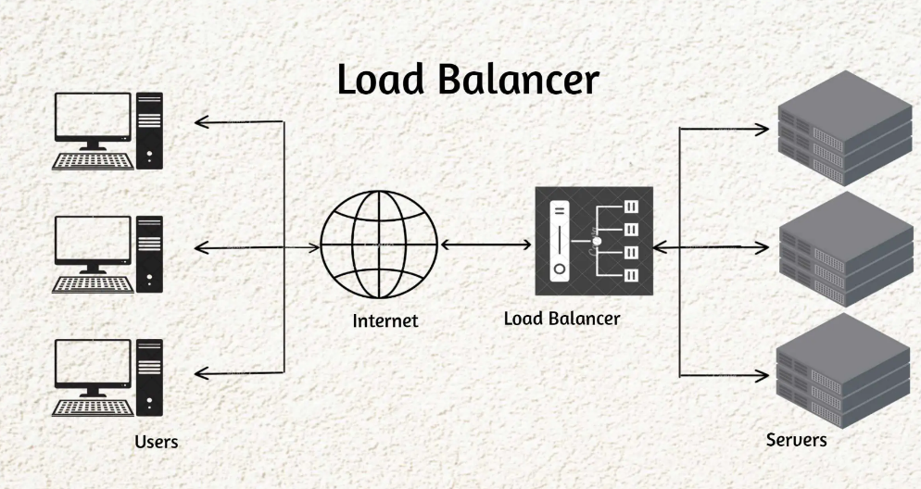
Fig: Basic Architecture of Load Balancer
In this lab, two virtual machines will host a web server. A load balancer will distribute traffic between them and automatically route traffic away from failed instances.

3. About Google Cloud Skills Boost
Google Cloud Skills Boost (skills.google) is an online platform that provides hands-on labs for Google Cloud services. It gives temporary access to a real Google Cloud project where students can safely perform experiments without affecting personal accounts.
To receive credit:
- Open skills.google in your browser.
- Click on Join, if you are new User.
- Click on Create Account with Google.
- Choose your Account and Continue.
- Enter your Date of Birth and Accept.
- Once the Pop up of “Start learning at no cost with GEAR” appears click on to participate.
- Choose Your Account and Continue
- In the Right Side, select your Experience, City/Town, I am a …, At … and Click Join.
- Now you will get 35 learning credits for being a GEAR member.
- Click on Start Learning.
4. Lab Procedure

Step 1: Log in to the Lab Console
- Open skill.google.
- Search for “Set Up Application Load Balancers”.
- Click on Start Lab and Launch with 1 Credit.
- Right Click on Open Google Cloud Console and open in Incognito Window.
- Accept the Terms and Condition and Continue.
Proceed only after the Google Cloud dashboard is visible.

Step 2: Navigate to VM Instances
- Click the Top Search Bar and Search for Compute Engine.
- Select Compute Engine.
- Click on Create Instances.

Step 3: Create Two Virtual Machines
Create VM 1
- Click Create instance.
- Set Name: web-1
- Keep region default and select a zone.
- Go to Networking and under Firewall, enable Allow HTTP Traffic.
- Click Create.
Create VM 2
Repeat the same steps:
- Name: web-2
- Keep region default and select a zone.
- Enable Allow HTTP traffic
- Click Create
Ensure both VMs are running before proceeding.

Step 4: Install Apache Web Server on Both VMs
On web-1
- Click web-1.
- Click SSH, and Authorize
- Run:
sudo apt update
sudo apt install -y apache2
echo "Hello from web-1" | sudo tee /var/www/html/index.html
- Close SSH.
On web-2
- Click web-2.
- Click SSH.
- Run:
sudo apt update
sudo apt install -y apache2
echo "Hello from web-2" | sudo tee /var/www/html/index.html
- Close SSH.

Step 5: Test Both VMs Directly
- Click the External IP of web-1.
Confirm it shows: Hello from web-1
- Click the External IP of web-2.
Confirm it shows: Hello from web-2

Step 6: Create an Unmanaged Instance Group
- Search for “Instance groups”.
- Click Create instance group.
- Select New unmanaged instance group.
Configuration:
- Name: web-ig
- Location: Zonal
- Zone: Same as VMs
In VM Instances, Add instances:
- Select web-1
- Select web-2
In Port Mapping, Add Named Port:
- Name: http
- Port: 80
Click Create.

Step 7: Create a Health Check
- Search for “Health checks”.
- Click Create health check.
Configuration:
- Name: http-health-check
- Protocol: HTTP
- Port: 80
Click Create.

Step 8: Create the Load Balancer
- Search for “Load balancing”.
- Click Create load balancer.
- Select Application Load Balancer.
- Rest all option keep it default.
- Click Continue.

Step 9: Configure Backend Service
- Name: web-lb
- Click on Backend Configuration and in Search Boc Click on the button called “Create a Backend Service”.
Set:
- Name: web-backend
- Backend type: Instance group
- Protocol: HTTP
- Named port: http
- Health check: http-health-check
Add backend:
- Select web-ig
Click Create.

Step 10: Configure Frontend
Set:
- Name: web-frontend
- Protocol: HTTP
- Port: 80
- IP address: Ephemeral
Click Create load balancer.
Wait 2–3 minutes for provisioning.

Step 11: Test Load Balancing
- Copy the Load Balancer IP address.
- Open it in a browser.
- Refresh multiple times.
You should alternately see:
- Hello from web-1
- Hello from web-2
This confirms traffic distribution.

Step 12: Fault Tolerance Demonstration
- Go to Compute Engine → VM instances.
- Stop or delete web-1.
- Refresh the Load Balancer IP.
The website should still work.
Only web-2 should respond.

5. Conclusion
In this lab, HTTP load balancing was successfully implemented using multiple virtual machine instances in Google Cloud Platform. An unmanaged instance group, health checks, and an Application Load Balancer were configured to distribute incoming traffic across backend servers.
The experiment demonstrated how load balancing improves system reliability by automatically redirecting traffic when a server becomes unavailable. This practical implementation highlights the importance of scalability, high availability, and fault tolerance in modern cloud-based systems.

